*A Project report on*

**DECENTRALIZED TRACEABILITY AND DIRECT MARKETING OF AGRICULTURAL SUPPLY CHAIN**

*Submitted in partial fulfilment of the requirements*

*for the award of the degree of*

**BACHELOR OF TECHNOLOGY**

*in*

**COMPUTER SCIENCE & ENGINEERING**

*By*

|  |  |
| --- | --- |
| **G. SAI PRANAV** | **(204G1A0590)** |

Under Guidance of

**Mr. M. Narasimhulu MTech (Ph.D.)**

Assistant Professor



**Department of Computer Science & Engineering**

**Srinivasa Ramanujan Institute of TECHNOLOGY**

**(AUTONOMOUS)**

**Rotarypuram Village, B K Samudram Mandal, Ananthapuramu - 515701**

**2023-2024**

**SRINIVASA RAMANUJAN INSTITUTE OF TECHNOLOGY**

**(AUTONOMOUS)**

(Affiliated to JNTUA, Accredited by NAAC with ‘A’ Grade, Approved by AICTE, New Delhi & Accredited by NBA (EEE, ECE & CSE)

Rotarypuram Village, BK Samudram Mandal, Ananthapuramu-515701

**DEPARTMENT OF COMPUTER SCIENCE & ENGINEERING**



**Certificate**

This is to certify that the Project report entitled **DECENTRALIZED TRACEABILITY AND DIRECT MARKETING OF AGRICULTURAL SUPPLY CHAIN** is the bonafide work carried out by **G. SAI PRANAV** bearing Roll Number **204G1A0590** in partial fulfilment of the requirements for the award of the degree of **Bachelor of Technology** in **Computer Science & Engineering** during the academic year 2023 - 2024.

### 

**Project Guide**

Mr. M. Narasimhulu M.Tech,(PhD)

Assistant Professor

**Head of the Department**

Mr. P. Veera Prakash M.Tech.(Ph.D.)

Assistant Professor & HOD

Date:

**EXTERNAL EXAMINER**

Place: Rotarypuram

# DECLARATION

I’m, Mr G. Sai Pranav bearing reg no: 204G1A0590 student of **SRINIVASA RAMANUJAN INSTITUTE OF TECHNOLOGY** , Rotarypuram , hereby declare that the dissertation entitled **“DECENTRALIZED TRACEABILITY AND DIRECT MARKETING OF AGRICULTURAL SUPPLY CHAIN”** embodies the report of my project work carried out by me during IV year Bachelor of Technology under the guidance of **Mr. M. Narasimhulu MTech.,(PhD)**. Department of CSE, **SRINIVASA RAMANUJAN INSTITUTE OF TECHNOLOGY**, and this work has been submitted in partial fulfilment of the requirements for the award of the degree of **Bachelor of Technology** in **Computer Science & Engineering** during the academic year 2023 - 2024.

The results embodied in this project have not been submitted to any other University of Institute for the award of any Degree or Diploma.

G. SAI PRANAV Reg no: 204G1A0590

# VISION & MISSION OF THE SRIT

**Vision:**

To become a premier Educational Institution in India offering the best teaching and learning environment for our students that will enable them to become complete individuals with professional competency, human touch, ethical values, service motto, and a strong sense of responsibility towards environment and society at large.

**Mission:**

* Continually enhance the quality of physical infrastructure and human resources to evolve in to a centre of excellence in engineering education.
* Provide comprehensive learning experiences that are conducive for the students to acquire professional competences, ethical values, life-long learning abilities and understanding of the technology, environment and society.
* Strengthen industry institute interactions to enable the students work on realistic problems and acquire the ability to face the ever-changing requirements of the industry.
* Continually enhance the quality of the relationship between students and faculty which is a key to the development of an exciting and rewarding learning environment in the college.

**VISION & MISSION OF THE DEPARTMENT OF CSE**

**Vision:**

To evolve as a leading department by offering best comprehensive teaching and learning practices for students to be self-competent technocrats with professional ethics and social responsibilities.

**Mission:**

DM 1: Continuous enhancement of the teaching-learning practices to gain profound knowledge in theoretical & practical aspects of computer science applications.

DM 2: Administer training on emerging technologies and motivate the students to inculcate self-learning abilities, ethical values and social consciousness to become competent professionals.

DM 3: Perpetual elevation of Industry-Institute interactions to facilitate the students to work on real-time problems to serve the needs of the society.

# ACKNOWLEDGEMENT

The satisfaction and euphoria that accompany the successful completion of any task would be incomplete without the mention of people who made it possible, whose constant guidance and encouragement crowned my efforts with success. It is a pleasant aspect that I have now the opportunity to express our gratitude for all of them.

It is with immense pleasure that I would like to express our indebted gratitude to our Guide **Mr. M. Narasimhulu, M.Tech, (PhD). ,Assistant Professor, Computer Science & Engineering**, who has guided me a lot and encouraged us in every step of the project work. I thank him for the stimulating guidance, constant encouragement and constructive criticism which have made possible to bring out this project work.

I express my deep-felt gratitude to **Mr. C. Lakshminatha Reddy, Assistant Professor** and **Mr. M. Narasimhulu, Assistant Professor,** Project Coordinators for their valuable guidance and unstinting encouragement enabled me to accomplish my project successfully in time.

I am very much thankful to **Mr. P. Veera Prakash, M.Tech., (Ph.D.), Assistant Professor & Head of the Department, Computer Science & Engineering,** for his kind support and for providing necessary facilities to carry out the work.

I wish to convey my special thanks to **Dr. G. Bala Krishna, Ph.D., Principal** of **Srinivasa Ramanujan Institute of Technology** for giving the required information in doing my project work. Not to forget, I thank all other faculty and non- teaching staff, and my friends who had directly or indirectly helped and supported me in completing my project in time.

I also express my sincere thanks to the Management for providing excellent facilities**.**

Finally, I wish to convey my gratitude to my family who fostered all the requirements and facilities that I need.

**G. SAI PRANAV**

**(204G1A0590)**

# ABSTRACT

The agriculture sector is facing the major challenges because of the absence of direct supply chain between farmers and buyers. This will lead to vulnerabilities, reduce the farmers income and compromises product quality. To address these issues, we are developing a web portal which facilitates the visibility of farmers profiles making their details accessible to the wide range of buyers. This approach lets buyers to connect with farmers through the portal, allowing them to negotiate and quickly update price agreements.

To enhance transparency and security, our system incorporates Blockchain technology to record and securely store all transactions. Our innovative web portal strives to bridge the gap between farmers and buyers promoting transparency and trust in agriculture transactions. This approach has the potential to benefit both farmers and consumers while promoting sustainable practices within the agricultural sector.

Food safety and corruption hazards have generated an enormous need of an effective traceability results icing to enough product’s safety within the husbandry force chain. Block chain is the revolutionary technological system, which provides the groundbreaking result for commodity traceableness in husbandry and in food force chains.

**Keywords:**

Agriculture supply chain, Direct marketing, Blockchain, Traceability.

CONTENTS **PAGE NO**

**List of Figures ix-x**

**List of Tables xi**

**List of Abbreviations xii**

**Chapter 1 Introduction 1**

* 1. Problem Statement 1
  2. Objectives 2
  3. Scope of Project 2

**Chapter 2 Literature Survey 3**

**Chapter 3 Methodology 7**

3.1 Blockchain 7

3.2 Algorithm Used 8

**Chapter 4 System Requirements Specifications 10**

4.1 Functional 10

4.2 Non-Functional Requirements 10

4.3 Python Libraries 11

4.3.1 Working of Python Library 11

4.3.2 Python Standard Library 12

4.3.3 Use of Libraries in Python Program 12

4.4 Hardware Requirements 13

4.5 Software Requirements 13

**Chapter 5 System Analysis and Design 14**

5.1 Introduction to Input and Output Design 14

5.1.1 Objectives of Input Design 14

5.1.2 Output Design 14

5.1.3 Objectives of Output Design 15

5.2 UML Diagrams 15

5.2.1 Use Case Diagram 15

5.2.2 Class Diagram 16

5.2.3 Sequence Diagram 16

5.2.4 Collaboration Diagram 17

5.2.5 Deployment Diagram 17

5.2.6 Activity Diagram 18

5.2.7 Component Diagram 19

5.2.8 ER Diagram 19

5.3 DFD Diagrams 20

5.4 System Architecture 21

5.5 Flowchart 22

**Chapter 6 Modules / Implementation 23**

6.1 Modules 23

6.1.1 Buyer 23

6.1.2 Seller 23

6.1.3 Admin 24

6.2 Implementation24

**Chapter 7 Testing 26**

7.1 Feasibility Study 26

7.1.1 Economical Feasibility 26

7.1.2 Technical Feasibility 26

7.1.3 Social Feasibility 27

7.1.4 System Feasibility 27

7.2 Unit Testing 27

7.3 Integration Testing 27

7.4 Functional Testing 28

7.5 White Box Testing 29

7.6 Black Box Testing 29

**Chapter 8 Results 32**

**CONCLUSION & FUTURE WORK 37**

**REFERENCES 38**

**PUBLICATION**

**CERTIFICATE**

# LIST OF FIGURES

**Figure No. Description Page No.**

5.1 Use Case Diagram 15

5.2 Class Diagram 16

5.3 Sequence Diagram 16

5.4 Collaboration Diagram 17

5.5 Deployment Diagram 18

5.6 Activity Diagram 18

5.7 Component Diagram 19

5.8 ER Diagram 20

5.9 Level 1 Diagram 21

5.10 Level 2 Diagram 21

5.11 System Architecture 22

5.12 Flowchart 22

6.1 Code for implementation of Blockchain 24

6.2 Code for Home Page 25

8.1 Home Page 31

8.2 Seller/ Farmer Login Page 31

8.3 Buyer Login Page 32

8.4 Admin Login Page 32

8.5 Seller Add Crop Information Page 33

8.6 Buyer Viewing Crop Information Page 33

8.7 Seller/Farmer Viewing Buyer Request 34

8.8 Buyer Viewing Response from Seller/Farmer 34

8.9 Payment Page 35

8.10 View Payment Page 35

# LIST OF TABLES

**Table No. Title Page No.**

7.1 Test Cases 30

7.2 Test cases model building 30

# LIST OF ABBREVIATIONS

UML

SHA

ER

DFD

Unified Modeling Language

Secured Hash Algorithm

Entity Relationship

Data Flow Diagram

# CHAPTER 1

# INTRODUCTION

In today's world, the agriculture supply chain faces numerous challenges, including transparency, traceability, and direct marketing. Farmers struggle to find reliable buyers for their crops, and buyers face challenges in sourcing quality products at fair prices. The farmers get less price than the minimum selling price in the market because of many intermediaries present in the current supply chain. There is no clear and reliable record about the crop, origin, quality, and the final price. There is no direct communication and negotiation between the farmer and the buyer. Lack of transparency in transactions makes it difficult for the farmer and the buyer to trust each other leading to disputes.

To address these issues, our project focus on the development of a decentralized traceability and direct marketing system for agriculture supply chains. This innovative system empowers buyers, sellers, and administrators, fostering a more efficient and transparent marketplace. Buyers can seamlessly register, log in, and access detailed information about sellers' crops, enabling them to make informed decisions. They can also send requests to sellers, view responses, make payments securely, and log out, ensuring a user-friendly experience. Sellers, on the other hand, can register and log in to provide comprehensive crop information, view buyer requests, and track payments effortlessly. This system streamlines the marketing process for sellers, improving their reach and efficiency. Administrators have the capability to log in, manage fixed payments, and maintain the system's integrity. Our decentralized traceability and direct marketing system promise to revolutionize agriculture supply chains, enhancing transparency, trust, and efficiency across the industry.

## 1.1 Problem Statement

The problem at hand revolves around the need for a comprehensive and decentralized traceability and direct marketing solution within agriculture supply chains. Currently, there is a lack of transparency and efficiency in connecting buyers and sellers in this industry. Buyers struggle to access reliable information on available crops, while sellers 5find it challenging to manage buyer requests and payments. This inefficiency leads to missed opportunities and potential fraud risks. The proposed system aims to address these issues by enabling buyers to register, login, view seller crop listings, send requests, make payments, and logout seamlessly. Sellers can register, login, provide crop information, view buyer requests and payments, and logout. Additionally, an admin interface allows for fixed payment processing. This innovative solution will streamline agricultural supply chains, foster trust, and promote fair and efficient trade.

## 1.2 Objectives

To accomplish the project's purpose, the following particular objectives have been established.

* To help farmers to sell their products in a direct and transparent manner by eliminating intermediaries.
* To bridge the gap between farmers and buyers, promoting transparency, traceability, and trust in agricultural transactions by providing a digital platform for them to connect which helps farmers to get better pricing for their crops.

## 1.3 Scope of the Project

The scope of this decentralized agriculture supply chain traceability and direct marketing system encompasses the development of a user-friendly platform for buyers, sellers, and an admin. Buyers can register, login, browse seller's crop listings, send purchase requests, view seller responses, make payments, and logout. Sellers can register, login, list their crops with detailed information, view buyer requests, and track payments before logging out. The admin's role is to manage crop prices. The system aims to streamline the agricultural supply chain, foster transparency, and facilitate efficient direct marketing interactions between buyers and sellers.

# CHAPTER – 2

# LITERATURE SURVEY

1. **M. M. Aung and Y. S. Chang, ‘‘Traceability in a food supply chain: Safety and quality perspectives,’’ Food Control, vol. 39, pp. 172–184, May 2014.**

The paper by M. M. Aung and Y. S. Chang, titled 'Traceability in a Food Supply Chain: Safety and Quality Perspectives' (2014), introduces the pivotal concept of traceability within the context of food supply chains. It acknowledges the growing importance of traceability in ensuring food safety and quality, especially in light of foodborne illness outbreaks and increasing consumer concerns. The introduction highlights the need for effective traceability systems to enhance transparency, reduce risks, and bolster consumer confidence in food products.

The proposed method in the paper focuses on implementing traceability systems within the food supply chain. It delves into the key components and processes necessary for effective traceability, such as data collection, tracking, and documentation of critical information at various stages of the supply chain. The authors emphasize the utilization of technologies and standards that enable the traceability of food products from farm to fork, aiming to improve food safety and quality.

In summary, Aung and Chang's paper underscores the vital role of traceability in enhancing food safety and quality. It emphasizes the need for comprehensive systems that facilitate accurate tracking and documentation of food products throughout the supply chain. The study underscores that such traceability systems are essential for preventing and mitigating food safety issues and for building consumer trust. By providing insights into the safety and quality perspectives, the paper contributes to the ongoing discussions on improving food supply chain management.

1. **T. Bosona and G. Gebresenbet, ‘‘Food traceability as an integral part of logistics management in food and agricultural supply chain,’’ Food Control, vol.**

**33, no. 2, pp. 32–48, 2013.**

In their 2013 study, T. Bosona and G. Gebresenbet examine "Food traceability as an integral part of logistics management in food and agricultural supply chain." The introduction sets the stage by emphasizing the growing importance of traceability in ensuring food safety and quality. It recognizes the complexities of modern supply chains and the need for an integrated approach to traceability in the food and agricultural sector.

The proposed method in the study underscores the significance of integrating traceability into logistics management within the food and agricultural supply chain. It outlines key components, such as data collection, information systems, and technology adoption, to achieve seamless traceability. The method suggests that by incorporating traceability as an essential aspect of logistics management, supply chains can improve efficiency, mitigate risks, and enhance the overall quality and safety of food products.

In summary, Bosona and Gebresenbet's research underscores the critical role of food traceability within logistics management for food and agricultural supply chains. They argue that a comprehensive approach to traceability is crucial to meet the demands of a complex and globalized supply chain system. Effective traceability systems not only enhance food safety and quality but also enable supply chain stakeholders to respond more efficiently to issues and recalls. By viewing traceability as integral to logistics, the study highlights the potential for supply chains to become more robust, transparent, and reliable.

1. **J. Hobbs, ‘‘Liability and traceability in agri-food supply chains,’’ in Quantifying the Agri-Food Supply Chain. Springer, 2006, pp. 87–102.**

In J. Hobbs' 2006 work, 'Liability and Traceability in Agri-Food Supply Chains,' the introduction sets the stage by addressing the essential concepts of liability and traceability in agri-food supply chains. It emphasizes the growing concern over food safety and quality, highlighting the need for robust systems to trace products and assign responsibility throughout the supply chain.

Hobbs' paper suggests a method for enhancing traceability and managing liability in agri-food supply chains. The proposed method advocates for the implementation of standardized tracking and documentation systems, integrating information and communication technologies. This approach aims to improve transparency and accountability across the supply chain, offering a framework for efficient product tracing and risk management.

In summary, Hobbs' work underscores the significance of traceability and liability in agri-food supply chains, particularly in the context of ensuring food safety and quality. It highlights the potential benefits of improved tracking systems and the allocation of responsibility. The study advocates for the development and adoption of these methods to enhance the integrity and security of the agri-food supply chain.

1. **D. Mao, Z. Hao, F. Wang, and H. Li, ‘‘Novel automatic food trading system using consortium blockchain,’’ Arabian J. Sci. Eng., vol. 44, no. 4, pp. 3439–3455, Apr. 2018.**

The 2018 paper by D. Mao, Z. Hao, F. Wang, and H. Li, titled 'Novel Automatic Food Trading System Using Consortium Blockchain,' introduces the concept of an innovative food trading system. It highlights the need for efficient and secure food supply chain management, emphasizing the potential of consortium blockchain technology in achieving this goal. The introduction sets the stage for a novel approach to revolutionizing the food trade sector.

The proposed method in this study outlines the development and implementation of an automatic food trading system based on consortium blockchain technology. It describes how this system streamlines the food supply chain by incorporating various stakeholders, such as farmers, suppliers, and consumers. The blockchain ensures transparency, traceability, and security, enabling participants to engage in trustful transactions. Smart contracts play a pivotal role in automating and optimizing the trading processes, reducing inefficiencies, and enhancing the overall reliability of the food supply chain.

In summary, this research presents an innovative solution to revolutionize the food trading industry. By leveraging consortium blockchain and smart contracts, it creates a secure and efficient ecosystem for all stakeholders. The system enhances transparency, traceability, and trust, addressing critical issues in food supply chain management. It offers promising prospects for automating and optimizing food trade processes, reducing costs, and ensuring the integrity and safety of food products from source to consumption.

1. **L. U. Opara and F. Mazaud, ‘‘Food traceability from field to plate,’’ Outlook Agricult., vol. 30, no. 2, pp. 239–247, 2001.**

In their 2001 paper titled "Food Traceability from Field to Plate," L. U. Opara and F. Mazaud set the stage by emphasizing the critical importance of food traceability in the agricultural and food industry. They acknowledge the increasing concerns about food safety, quality, and authenticity among consumers and regulatory bodies. The introduction highlights the growing need for systems that can trace food products from their origin to consumers' plates to address these concerns and enhance the overall integrity of the food supply chain.

Opara and Mazaud's proposed method outlines a comprehensive framework for implementing food traceability. It stresses the necessity of standardized tracking and documentation systems throughout the entire supply chain. The authors discuss the vital components of effective traceability, which encompass data collection from the field, processing, distribution, and retail stages. Their approach integrates technologies and information systems to capture and record essential data points such as batch numbers, production dates, and the origin of products. This allows for the seamless flow of information from the field to the final consumer, ensuring transparency and accountability at every stage of the supply chain.

In summary, Opara and Mazaud's research underscores the significance of food traceability as a fundamental solution to enhance food safety and quality. Their proposed method showcases the role of advanced technologies in streamlining data collection and sharing, which can substantially reduce the risks associated with foodborne illnesses, while also bolstering consumer confidence. By emphasizing traceability and accountability, their approach contributes to more efficient supply chain management, offering benefits for both producers and consumers, ultimately supporting safer and higher-quality food products.

# CHAPTER – 3

# METHODOLOGY

## 3.1 Blockchain

A blockchain is a distributed database or ledger shared among a computer network's nodes. They are best known for their crucial role in cryptocurrency systems for maintaining a secure and decentralized record of transactions, but they are not limited to cryptocurrency uses. Blockchains can be used to make data in any industry immutable—the term used to describe the inability to be altered. Because there is no way to change a block, the only trust needed is at the point where a user or program enters data. This aspect reduces the need for trusted third parties, which are usually auditors or other humans that add costs and make mistakes.

A blockchain is somewhat similar to spreadsheets or databases because it is a database where information is entered and stored. But the key difference between a traditional database or spreadsheet and a blockchain is how the data is structured and accessed. A blockchain consists of programs called scripts that conduct the tasks you usually would in a database: Entering and accessing information and saving and storing it somewhere. A blockchain is distributed, which means multiple copies are saved on many machines, and they must all match for it to be valid.

The blockchain collects transaction information and enters it into a block, like a cell in a spreadsheet containing information. Once it is full, the information is run through an encryption algorithm, which creates a hexadecimal number called the hash. The hash is then entered into the following block header and encrypted with the other information in the block. This creates a series of blocks that are chained together.

**Blockchain Decentralization**

A blockchain allows the data in a database to be spread out among several network nodes—computers or devices running software for the blockchain—at various locations. This not only creates redundancy but maintains the fidelity of the data. For example, if someone tries to alter a record at one instance of the database, the other nodes would prevent it from happening. This way, no single node within the network can alter information held within it. Because of this distribution—and the encrypted proof that work was done—the information and history (like the transactions) are irreversible. Such a record could be a list of transactions but it also is possible for a blockchain to hold a variety of other information like legal contracts, state identifications, or a company’s inventory.

**Blockchain Transparency**

Because of the decentralized nature, all transactions can be transparently viewed by either having a personal node or using blockchain explorers that allow anyone to see transactions occurring live. Each node has its own copy of the chain that gets updated as fresh blocks are confirmed and added.

## 3.2 Algorithm Used

Decentralized SHA-256-based Update Function

* keyGen((1𝑙, 1 𝑛) 𝑖∈[1,𝑛]) → (𝑠𝑘𝑖): each entity 𝑈𝑖 takes a certain security parameter 𝑙 and the number of entities 𝑛, and outputs a private key 𝑠𝑘𝑖.Each entity 𝑈𝑖 initiates the key generation process by taking a security parameter 𝑙 and the total number of entities 𝑛 as inputs.The output is a private key 𝑠𝑘𝑖 unique to each entity 𝑈𝑖, generated using the SHA-256-based key generation method.
* hash(𝑚𝑠𝑔) → ℎ: each entity 𝑈𝑖 takes a message 𝑚𝑠𝑔 and outputs a hash value ℎ using SHA-256. Entities take a message 𝑚𝑠𝑔 as input and utilize the SHA-256 algorithm to produce a hash value ℎ. The resulting hash ℎ serves as a secure representation of the input message.
* update((𝑠𝑘𝑖, 𝑚𝑠𝑔)) → ℎ′: each entity 𝑈𝑖 takes its private key 𝑠𝑘𝑖 and a message 𝑚𝑠𝑔. Then, 𝑈𝑖 outputs an updated hash value ℎ′ using SHA-256. Each entity 𝑈𝑖, armed with its private key 𝑠𝑘𝑖 and a message 𝑚𝑠𝑔, updates the hash value using the SHA-256 algorithm.The output is an updated hash value ℎ′, reflecting the incorporation of the private key and the new message into the original hash.
* verify(𝑚𝑠𝑔, ℎ, ℎ′) → 0Ú1: each entity 𝑈𝑖 takes an original message 𝑚𝑠𝑔, the original hash value ℎ, and the updated hash value ℎ′. Then, 𝑈𝑖 outputs 0/1 to indicate whether the update is invalid or valid.Entities undertake the verification process by taking the original message 𝑚𝑠𝑔, the original hash value ℎ, and the updated hash value ℎ′ as inputs.The output is binary, with '0' indicating an invalid update and '1' signifying a valid update. This process ensures the integrity and authenticity of the updated information.

**Key Generation:**

The algorithm begins by establishing a decentralized system's cryptographic foundation, focusing on private key generation and message hashing for secure data transmission. In the key generation process, an empty list is initiated to store private Data Consistency Verification in Blockchain Computer Science & Engineering, SRIT Page 15 keys, each uniquely formed by combining literals and numbers into a tuple, which is subsequently hashed using the SHA-256 algorithm. The resulting hashed private keys form a set stored in the list. Following this, the algorithm transitions to message hashing, where input messages slated for secure transmission undergo SHA-256 hashing, producing hash values that serve as compact, secure representations. These private keys and message hash values are pivotal in enhancing data security, integrity, and authenticity within decentralized systems, particularly in the context of cryptographic protocols and blockchain applications.

|  |
| --- |
| Step 1: Key Generation  1.1. Start with an empty list to store private keys.  1.2. For each index 'i' from 1 to 'n' (where 'n' is the desired number of private keys): Generate a combination of literals (1l) and numbers (1n) to create a unique private key. Combine the literals and numbers to form a tuple (key_literal, key_number).  1.3.Hash the combined tuple using the SHA-256 algorithm to create a hashed private key.  1.4.Add the hashed private key to the list of private keys.  1.5.Repeat steps 1.2 to 1.4 for the desired number of private keys ('n').  1.6.The list now contains the set of private keys (Ski)ni=1.  Step 2: Message Hashing  2.1. Take the input message (msg) that needs to be securely transmitted.  2.2. Use the SHA-256 algorithm to hash the message.  2.3. The output of this step is the hash value (h) derived from the original. |

# CHAPTER – 4

# SYSTEM REQUIREMENTS SPECIFICATIONS

Requirement’s analysis is very critical process that enables the success of a system or software project to be assessed. Requirements are generally split into two types: Functional and non-functional requirements.

## 4.1 Functional Requirements:

These are the requirements that the end user specifically demands as basic facilities that the system should offer. All these functionalities need to be necessarily incorporated into the system as a part of the contract. These are represented or stated in the form of input to be given to the system, the operation performed and the output expected. They are basically the requirements stated by the user which one can see directly in the final product, unlike the non-functional requirements. Examples of functional requirements:

* Traceability System: Implement a decentralized traceability system to track the journey of agricultural products from farm to consumer.
* Data Management: Store relevant data including product origin, production methods, transportation details, and certifications securely on the blockchain.
* Direct Marketing Platform: Develop a platform where farmers can directly market their products to consumers, bypassing intermediaries.
* Consumer Interface: Create a user-friendly interface for consumers to access information about the products they purchase, including farm details and sustainability practices.

## 4.2 Non-functional requirements:

These are basically the quality constraints that the system must satisfy according to the project contract. The priority or extent to which these factors are implemented varies from one project to other. They are also called non-behavioural requirements.

They basically deal with issues like:

* Security: Ensure data integrity and confidentiality through robust encryption and access control measures.
* Scalability: Design the system to handle a large volume of transactions as the platform grows.
* Usability: Prioritize intuitive design and navigation to accommodate users with varying levels of technological proficiency.
* Performance: Maintain high system availability and response times to support real-time tracking and marketing activities.
* Compliance: Adhere to regulatory standards for data protection and food safety throughout the supply chain process.

## 4.3 Python Libraries:

Normally, a library is a collection of books or is a room or place where many books are stored to be used later. Similarly, in the programming world, a library is a collection of precompiled codes that can be used later on in a program for some specific well-defined operations. Other than pre-compiled codes, a library may contain documentation, configuration data, message templates, classes, and values, etc.

A Python library is a collection of related modules. It contains bundles of code that can be used repeatedly in different programs. It makes Python Programming simpler and convenient for the programmer. As we don’t need to write the same code again and again for different programs. Python libraries play a very vital role in fields of Machine Learning, Data Science, Data Visualization, etc.

### 4.3.1 Working of Python Library

As is stated above, a Python library is simply a collection of codes or modules of codes that we can use in a program for specific operations. We use libraries so that we don’t need to write the code again in our program that is already available. But how it works. Actually, in the MS Windows environment, the library files have a DLL extension (Dynamic Load Libraries). When we link a library with our program and run that program, the linker automatically searches for that library. It extracts the functionalities of that library and interprets the program accordingly. That’s how we use the methods of a library in our program. We will see further, how we bring in the libraries in our Python programs.

### 4.3.2 Python standard library

The Python Standard Library contains the exact syntax, semantics, and tokens of Python. It contains built-in modules that provide access to basic system functionality like I/O and some other core modules. Most of the Python Libraries are written in the C programming language. The Python standard library consists of more than 200 core modules. All these works together to make Python a high-level programming language. Python Standard Library plays a very important role. Without it, the programmers can’t have access to the functionalities of Python. But other than this, there are several other libraries in Python that make a programmer’s life easier. Let’s have a look at some of the commonly used libraries:

* **Pandas:** Pandas are an important library for data scientists. It is an open-source machine learning library that provides flexible high-level data structures and a variety of analysis tools. It eases data analysis, data manipulation, and cleaning of data. Pandas support operations like Sorting, Re-indexing, Iteration, Concatenation, Conversion of data, Visualizations, Aggregations, etc.
* **Numpy:** The name “Numpy” stands for “Numerical Python”. It is the commonly used library. It is a popular machine learning library that supports large matrices and multi-dimensional data. It consists of in-built mathematical functions for easy computations. Even libraries like TensorFlow use Numpy internally to perform several operations on tensors. Array Interface is one of the key features of this library.
* **Flask:** Flask is a micro web framework written in Python. It is classified as a micro framework because it does not require particular tools or libraries.[[2]](https://en.wikipedia.org/wiki/Flask_(web_framework)#cite_note-2) It has no database abstraction layer, form validation, or any other components where pre-existing third-party libraries provide common functions. However, Flask supports extensions that can add application features as if they were implemented in Flask itself. Extensions exist for object-relational mappers, form validation, upload handling, various open authentication technologies and several common framework related tools.

### 4.3.3 Use of Libraries in Python Program

As we write large-size programs in Python, we want to maintain the code’s modularity. For the easy maintenance of the code, we split the code into different parts and we can use that code later ever we need it. In Python, modules play that part. Instead of using the same code in different programs and making the code complex, we define mostly used functions in modules and we can just simply import them in a program wherever there is a requirement. We don’t need to write that code but still, we can use its functionality by importing its module. Multiple interrelated modules are stored in a library. And whenever we need to use a module, we import it from its library. In Python, it’s a very simple job to do due to its easy syntax. We just need to use **import**.

## 4.4 Hardware Requirements

|  |  |
| --- | --- |
| Processor | - I3/Intel Processor |
| Hard Disk | - 160GB |
| Key Board | - Standard Windows Keyboard |
| Mouse | - Two or Three Button Mouse |
| Monitor | - SVGA |
| RAM 4.5 Software Requirements | - 8GB |
| Operating System | : Windows 7/8/10 |
| Server-side Script | : HTML, CSS, Bootstrap & JS |
| Programming Language | : Python |
| Libraries | : Flask, Pandas, MySQL. connector, OS, Smtplib,  NumPy |
| IDE/Workbench | : Visual Studio Code |
| Technology | : Python 3.6+ |
| Server Deployment | : XAMPP Server |
| Database | : MySQL |

# CHAPTER – 5

# SYSTEM ANAYSIS AND DESIGN

## 5.1 Introduction to Input and Output Design:

In an information system, input is the raw data that is processed to produce output. During the input design, the developers must consider the input devices such as PC, MICR, OMR, etc.

Therefore, the quality of system input determines the quality of system output. Well-designed input forms and screens have following properties −

* It should serve specific purpose effectively such as storing, recording, and retrieving the information.
* It ensures proper completion with accuracy.
* It should be easy to fill and straightforward.
* It should focus on user’s attention, consistency, and simplicity.
* All these objectives are obtained using the knowledge of basic design principles regarding –
* What are the inputs needed for the system?
* How end users respond to different elements of forms and screens.

### 5.1.1 Objectives of Input Design:

The objectives of input design are −

* To design data entry and input procedures
* To reduce input volume
* To design source documents for data capture or devise other data capture methods
* To design input data records, data entry screens, user interface screens, etc.
* To use validation checks and develop effective input controls.

### 5.1.2 Output Design:

The design of output is the most important task of any system. During output design, developers identify the type of outputs needed, and consider the necessary output controls and prototype report layouts.

### 5.1.3 Objectives of Output Design:

The objectives of input design are:

* To develop output design that serves the intended purpose and eliminates the production of unwanted output.
* To develop the output design that meets the end user’s requirements.
* To deliver the appropriate quantity of output.
* To form the output in appropriate format and direct it to the right person.
* To make the output available on time for making good decisions.

## 5.2 UML DIAGRAMS

### 5.2.1 Use Case Diagram:

A use case diagram in the Unified Modelling Language (UML) is a type of behavioural diagram defined by and created from a Use-case analysis. Its purpose is to present a graphical overview of the functionality provided by a system in terms of actors, their goals (represented as use cases), and any dependencies between those use cases. The main purpose of a use case diagram is to show what system functions are performed for which actor. Roles of the actors in the system can be depicted.

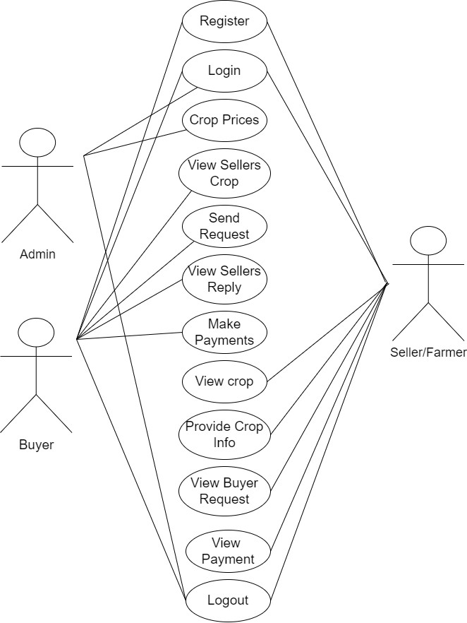

FIGURE 5.1: Use Case Diagram

### 5.2.2 Class Diagram:

In software engineering, a class diagram in the Unified Modelling Language (UML) is a type of static structure diagram that describes the structure of a system by showing the system's classes, their attributes, operations (or methods), and the relationships among the classes. It explains which class contains information.

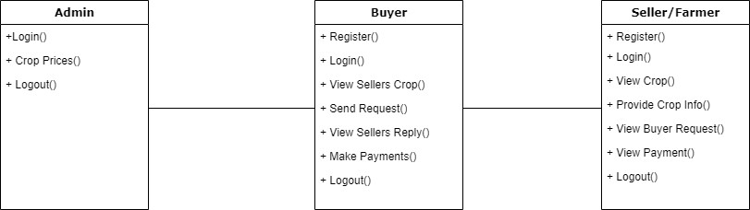

FIGURE 5.2: Class Diagram

### 5.2.3 Sequence Diagram:

A sequence diagram in Unified Modelling Language (UML) is a kind of interaction diagram that shows how processes operate with one another and in what order. It is a construct of a Message Sequence Chart. Sequence diagrams are sometimes called event diagrams, event scenarios, and timing diagrams.

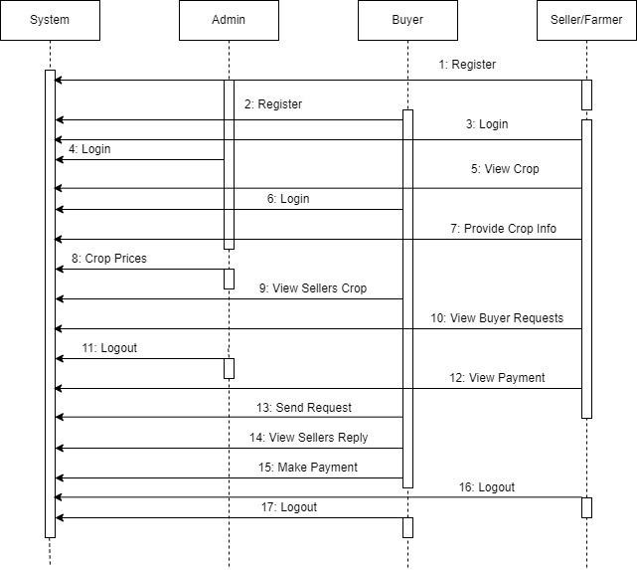

FIGURE 5.3: Sequence Diagram

### 5.2.4 Collaboration Diagram:

In collaboration diagram the method call sequence is indicated by some numbering technique as shown below. The number indicates how the methods are called one after another. We have taken the same order management system to describe the collaboration diagram. The method calls are similar to that of a sequence diagram. But the difference is that the sequence diagram does not describe the object organization whereas the collaboration diagram shows the object organization.

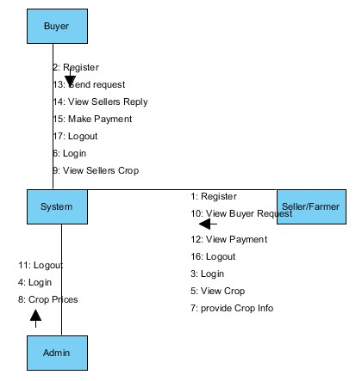

FIGURE 5.4: Collaboration Diagram

### 5.2.5 Deployment Diagram

Deployment diagram represents the deployment view of a system. It is related to the component diagram. Because the components are deployed using the deployment diagrams. A deployment diagram consists of nodes. Nodes are nothing but physical hardware’s used to deploy the application.

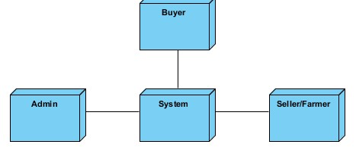

FIGURE 5.5: Deployment Diagram

### 5.2.6 Activity Diagram:

Activity diagrams are graphical representations of workflows of stepwise activities and actions with support for choice, iteration and concurrency. In the Unified Modelling Language, activity diagrams can be used to describe the business and operational step-by-step workflows of components in a system. An activity diagram shows the overall flow of control.

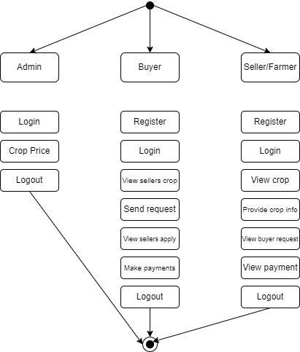

FIGURE 5.6: Activity Diagram

### 5.2.7 Component Diagram:

A component diagram, also known as a UML component diagram, describes the organization and wiring of the physical **c**omponents in a system. Component diagrams are often drawn to help model implementation details and double-check that every aspect of the system's required functions is covered by planned development.

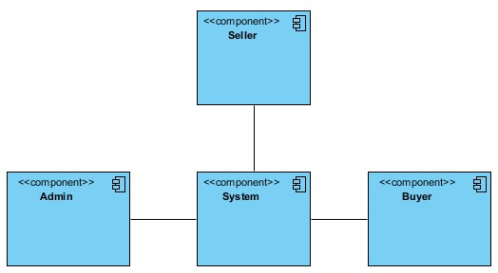

FIGURE 5.7: Component Diagram

### 5.2.8 ER Diagram:

An Entity–relationship model (ER model) describes the structure of a database with the help of a diagram, which is known as Entity Relationship Diagram (ER Diagram). An ER model is a design or blueprint of a database that can later be implemented as a database. The main components of E-R model are: entity set and relationship set.

An ER diagram shows the relationship among entity sets. An entity set is a group of similar entities and these entities can have attributes. In terms of DBMS, an entity is a table or attribute of a table in database, so by showing relationship among tables and their attributes, ER diagram shows the complete logical structure of a database. Let’s have a look at a simple ER diagram to understand this concept.

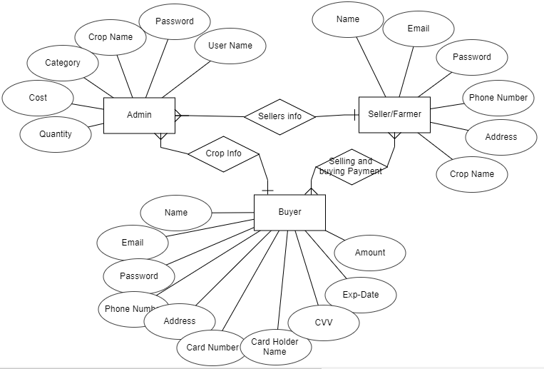

FIGURE 5.8: ER Diagram

## 5.3 DFD Diagram:

A Data Flow Diagram (DFD) is a traditional way to visualize the information flows within a system. A neat and clear DFD can depict a good amount of the system requirements graphically. It can be manual, automated, or a combination of both. It shows how information enters and leaves the system, what changes the information and where information is stored. The purpose of a DFD is to show the scope and boundaries of a system as a whole. It may be used as a communications tool between a systems analyst and any person who plays a part in the system that acts as the starting point for redesigning a system.

**Level 1 Diagram:**

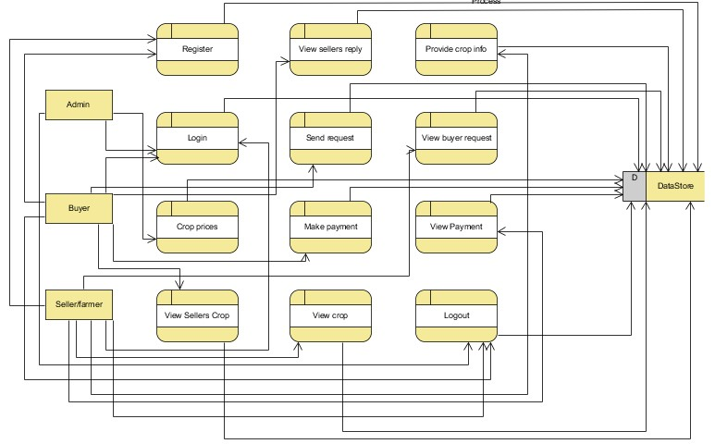

FIGURE 5.9: Level 1 Diagram

**Level 2 Diagram:**

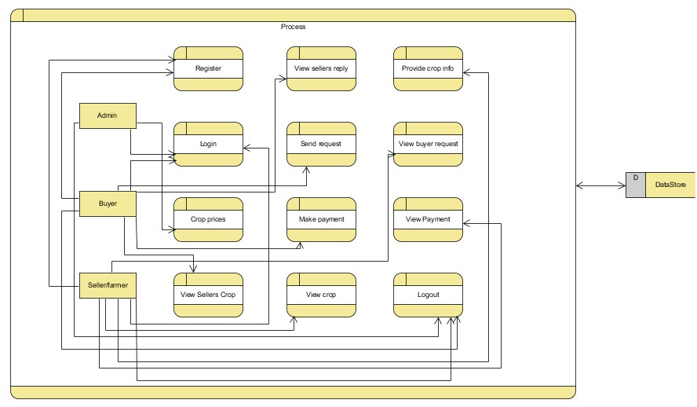

FIGURE 5.10: Level 2 Diagram

## 5.4 System Architecture

Architecture diagrams can help system designers and developers visualize the high-level, overall structure of their system or application for the purpose of ensuring the system meets their users' needs. They can also be used to describe patterns that are used throughout the design. It's somewhat like a blueprint that can be used as a guide for the convenience of discussing, improving, and following among a team.

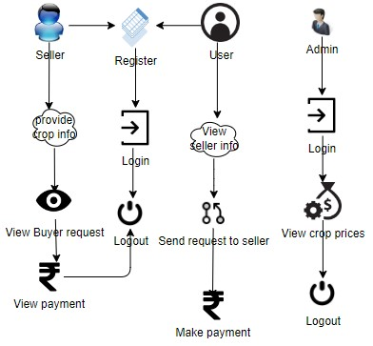

FIGURE 5.11: System Architecture

## 5.5 Flowchart

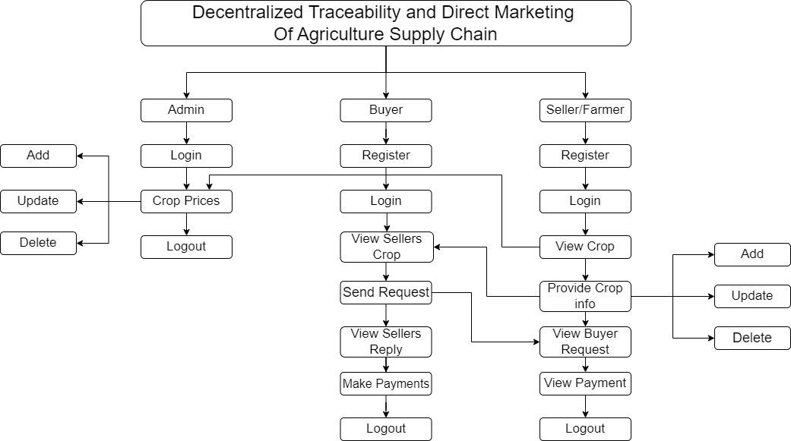

FIGURE 5.12: Flowchart

# CHAPTER – 6

# MODULES / IMPLEMENTATION

## 6.1 Modules

To develop a decentralized traceability for agriculture supply chains, you can break down the functionality into several modules for the different user roles: Buyer, Seller, and Admin. Here are the modules for each role:

### 6.1.1 Buyer:

**Register:** The buyer will register with their details like name, email, password, address, contact, so after that the buyer will login.

**Login:** After registration the buyer will login with their details.

**View Seller's Crop Information:** Once the sellers will add the details the buyer can view those details here.

**Send Request to Seller:** If the buyer wants the details of crop then buyer will send request to seller.

**View Seller Requests:** Displays responses from sellers to the buyer's requests.

**Make Payment:** Once the seller accept the request for the crop the buyer has to pay the amount for that crop.

**Logout:** Allows buyers to logout securely.

### 6.1.2 Seller:

**Register:** The seller will register with their details like name, email, password, address, contact, so after that the seller will login.

**Login:** After registration the seller will login with their details.

**Provide Crop Information:** The seller will add their crop details like (crop name, crop category, and quantity and quality).

**View Buyer Requests:** When the buyer will send the request for the crop, here the buyer will view and he/she has to accept the request.

**View Payments:** Once the buyer will pay the amount for the crops. The seller can view the details of the payment.

**Logout:** Allows sellers to logout securely.

### 6.1.3 Admin:

**Login:** The admin will login with default email and password.

**Crop price:** The admin is the person he/ she will add the crop price for each and every crop details with that crop name, category, maximum cost, minimum cost and quantity.

**Logout:** Allows the admin to log out securely.

## 6.2 Implementation

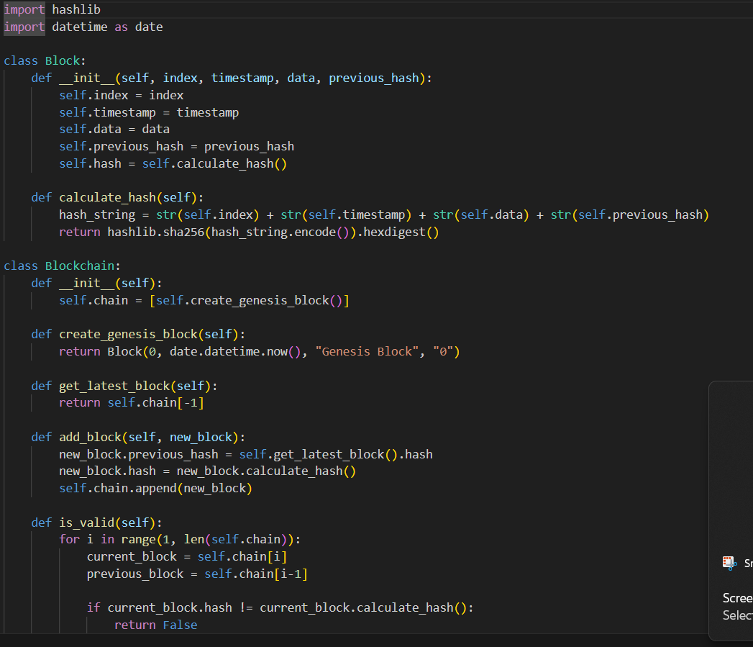

FIGURE 6.1: Code for implementation of Blockchain

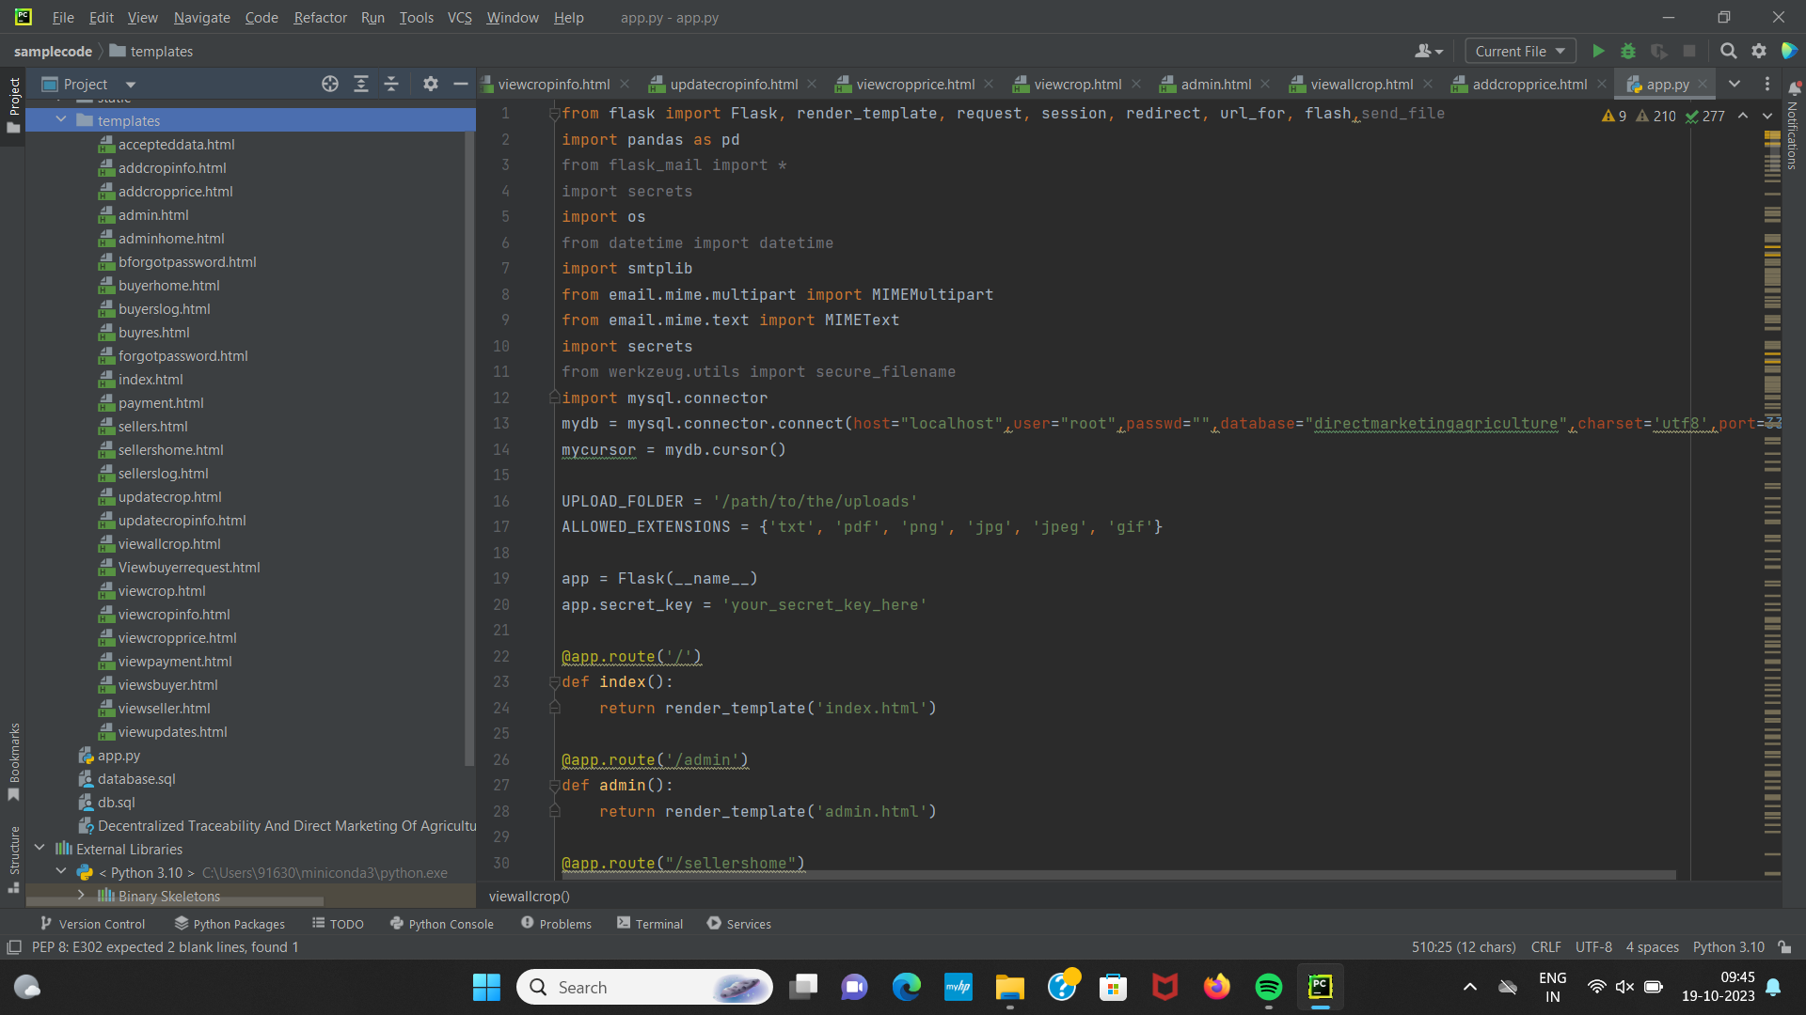

FIGURE 6.2: Code for Home Page

# CHAPTER – 7

# SYSTEM STUDY AND TESTING

## 7.1 Feasibility Study

The feasibility of the project is analysed in this phase and business proposal is put forth with a very general plan for the project and some cost estimates. During system analysis the feasibility study of the proposed system is to be carried out. This is to ensure that the proposed system is not a burden to the company. For feasibility analysis, some understanding of the major requirements for the system is essential.

Three key considerations involved in the feasibility analysis are

* Economical feasibility
* Technical feasibility
* Social feasibility

### 7.1.1 Economical Feasibility

This study is carried out to check the economic impact that the system will have on the organization. The amount of fund that the company can pour into the research and development of the system is limited. The expenditures must be justified. Thus the developed system as well within the budget and this was achieved because most of the technologies used are freely available. Only the customized products had to be purchased.

### 7.1.2 Technical Feasibility

This study is carried out to check the technical feasibility, that is, the technical requirements of the system. Any system developed must not have a high demand on the available technical resources. This will lead to high demands on the available technical resources. This will lead to high demands being placed on the client. The developed system must have a modest requirement, as only minimal or null changes are required for implementing this system.

### 7.1.3 Social Feasibility

The aspect of study is to check the level of acceptance of the system by the user. This includes the process of training the user to use the system efficiently. The user must not feel threatened by the system, instead must accept it as a necessity. The level of acceptance by the users solely depends on the methods that are employed to educate the user about the system and to make him familiar with it. His level of confidence must be raised so that he is also able to make some constructive criticism, which is welcomed, as he is the final user of the system.

### 7.1.4 System Testing

The purpose of testing is to discover errors. Testing is the process of trying to discover every conceivable fault or weakness in a work product. It provides a way to check the functionality of components, sub-assemblies, assemblies and/or a finished product It is the process of exercising software with the intent of ensuring that the software system meets its requirements and user expectations and does not fail in an unacceptable manner. There are various types of tests. Each test type addresses a specific testing requirement.

## 7.2 Unit Testing

Unit testing involves the design of test cases that validate that the internal program logic is functioning properly, and that program inputs produce valid outputs. All decision branches and internal code flow should be validated. It is the testing of individual software units of the application .it is done after the completion of an individual unit before integration. This is a structural testing, that relies on knowledge of its construction and is invasive. Unit tests perform basic tests at component level and test a specific business process, application, and/or system configuration. Unit tests ensure that each unique path of a business process performs accurately to the documented specifications and contains clearly defined inputs and expected results.

## 7.3 Integration Testing

Integration tests are designed to test integrated software components to determine if they actually run as one program. Testing is event driven and is more concerned with the basic outcome of screens or fields. Integration tests demonstrate that although the components were individually satisfaction, as shown by successfully unit testing, the combination of components is correct and consistent. Integration testing is specifically aimed at exposing the problems that arise from the combination of components.

Software integration testing is the incremental integration testing of two or more integrated software components on a single platform to produce failures caused by interface defects.

The task of the integration test is to check that components or software applications, e.g. components in a software system or – one step up – software applications at the company level – interact without error.

**Test Results:**

All the test cases mentioned above passed successfully. No defects encountered. **Acceptance Testing**

User Acceptance Testing is a critical phase of any project and requires significant participation by the end user. It also ensures that the system meets the functional requirements.

All the test cases mentioned above passed successfully. No defects encountered.

## 7.4 Functional testing:

Functional tests provide systematic demonstrations that functions tested are available as specified by the business and technical requirements, system documentation, and user manuals.

Functional testing is centered on the following items:

Valid Input : identified classes of valid input must be accepted.

Invalid Input : identified classes of invalid input must be rejected.

Functions : identified functions must be exercised.

Output : identified classes of application outputs must be exercised.

Systems/Procedures: interfacing systems or procedures must be invoked.

Organization and preparation of functional tests is focused on requirements, key functions, or special test cases. In addition, systematic coverage pertaining to identify Business process flows; data fields, predefined processes, and successive processes must be considered for testing. Before functional testing is complete, additional tests are identified and the effective value of current tests is determined.

## 7.6 White Box Testing

White Box Testing is a testing in which in which the software tester has knowledge of the inner workings, structure and language of the software, or at least its purpose. It is purpose. It is used to test areas that cannot be reached from a black box level.

## 7.7 Black Box Testing

Black Box Testing is testing the software without any knowledge of the inner workings, structure or language of the module being tested. Black box tests, as most other kinds of tests, must be written from a definitive source document, such as specification or requirements document, such as specification or requirements document. It is a testing in which the software under test is treated, as a black box, you cannot “see” into it. The test provides inputs and responds to outputs without considering how the software works.

**Test objectives**

* All field entries must work properly.
* Pages must be activated from the identified link.
* The entry screen, messages and responses must not be delayed.

**Features to be tested**

* Verify that the entries are of the correct format
* No duplicate entries should be allowed
* All links should take the user to the correct page.

**Test Case**

Table 7.1: Test Case

|  |  |  |
| --- | --- | --- |
| **Input** | **Output** | **Result** |
| Input image | Decentralized traceability and direct marketing of agriculture supply chains | Success |

**Test cases model building:**

Table 7.2: Test cases model building:

|  |  |  |  |  |  |
| --- | --- | --- | --- | --- | --- |
| **S.NO** | **Test cases** | **I/O** | **Expected O/T** | **Actual O/T** | **P/F** |
| 1 | Register Sellers | Enter name, email, contact, address. | Data added  successfully | Added  successfully | P |
| 2 | Login Sellers | Enter email and password | Login successfully | Login success | P |
| 3 | Login Sellers | Enter email and password | Password not matched | Login fail | F |
| 4 | Add crop  info | Enter crop name, category, quantity | Data added  successfully | Added  successfully | P |
| 5 | Login admin | Enter email and password | Login successful | Login success | p |
| 6 | Login admin | Enter email and password | Login successful | Login failed | F |

# CHAPTER – 8

# RESULTS

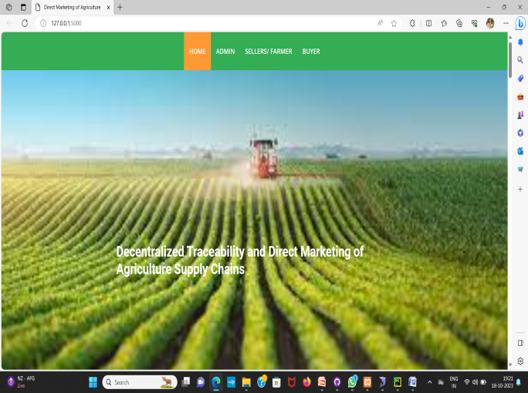

FIGURE 8.1:Home Page

The home page contains link to admin login page, farmer/seller login page and buyer login page.

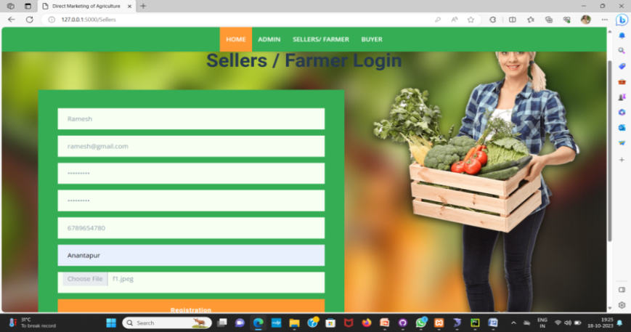

FIGURE 8.2: Seller / Farmer Login Page

The Seller/Farmer can login by registering themselves using mail-id, phone number and password.

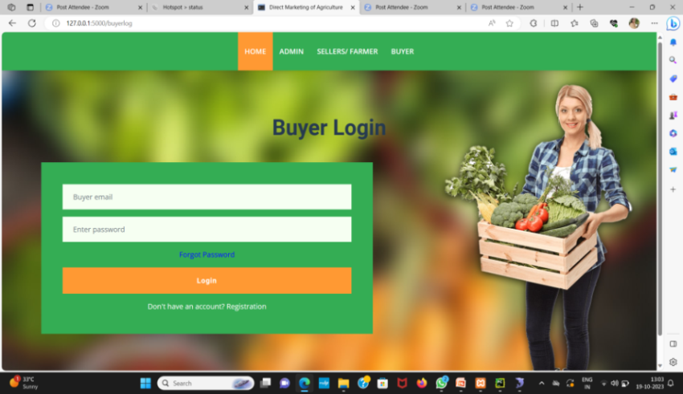

FIGURE 8.3:Buyer Login Page

The buyer can login by registering themselves using mail-id, phone number and password.

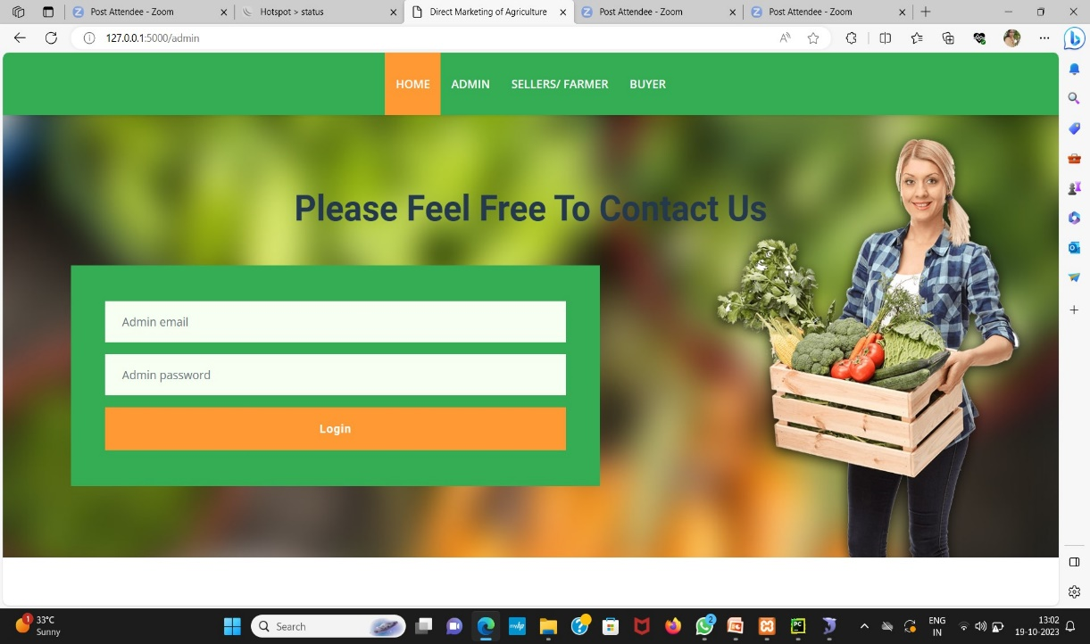

FIGURE 8.4: Admin Login Page

The admin can login by using the admin email and password.

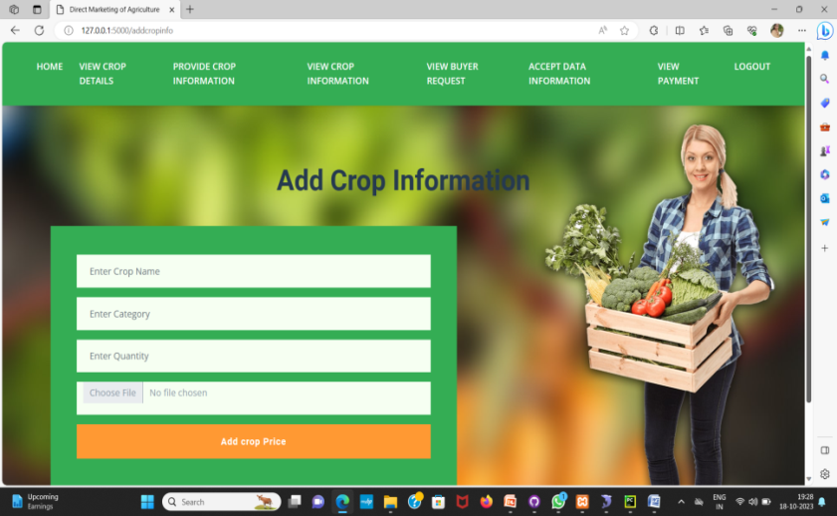

FIGURE 8.5:SellerAdd Crop Information Page

The Seller can add the crop information like name of the crop, category of the crop, quantity of the total yield and the picture of it.

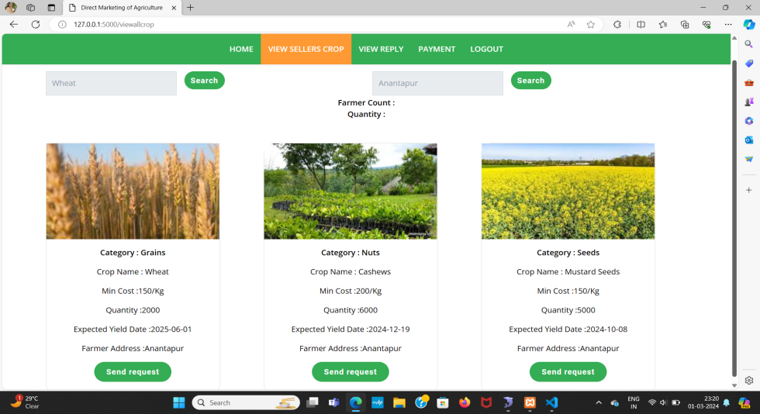

FIGURE 8.6:Buyer Viewing Crop Information Page

The Buyer can view the crop information provided by different farmers. They can even filter the results using the crop name and the location.

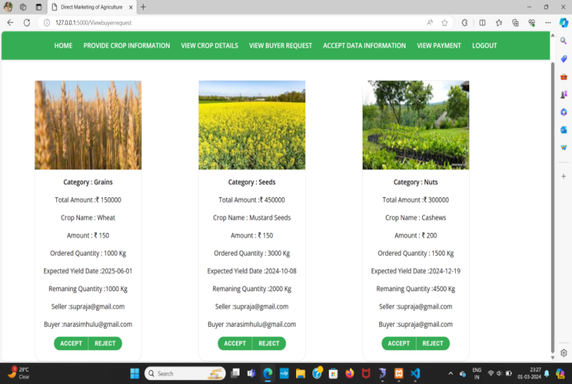

FIGURE 8.7:Seller / Farmer Viewing Buyer’s Request

The Seller/Farmer can view the requests sent by the buyer. The buyer can send request by mentioning the crop and the quantity needed. The request can be accepted or rejected by the seller.

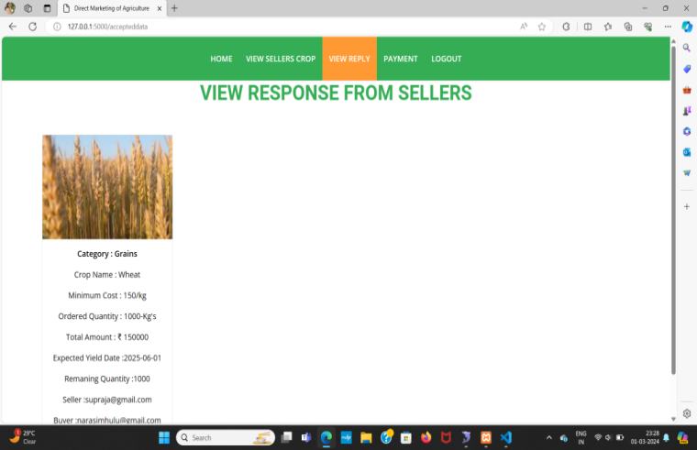

FIGURE 8.8:BuyerViewing Response from Seller / Farmer

The buyer can view the response from the seller/farmer to know if their request is accepted or not.

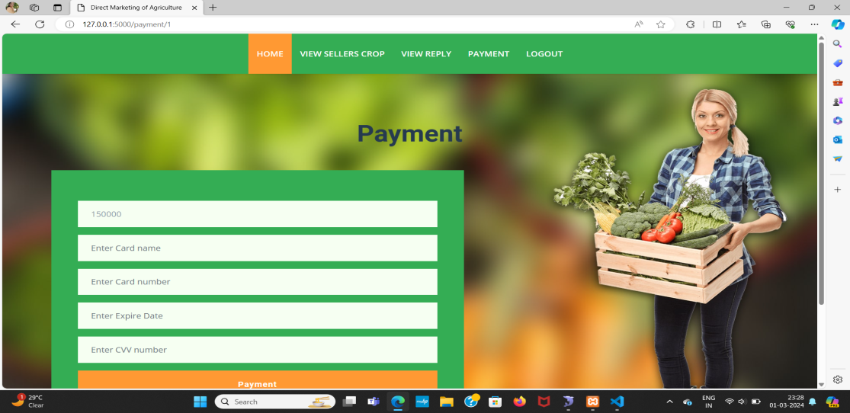

FIGURE 8.9:Payment Page

If the seller accepts the buyer’s request, the buyer can proceed with the payment.

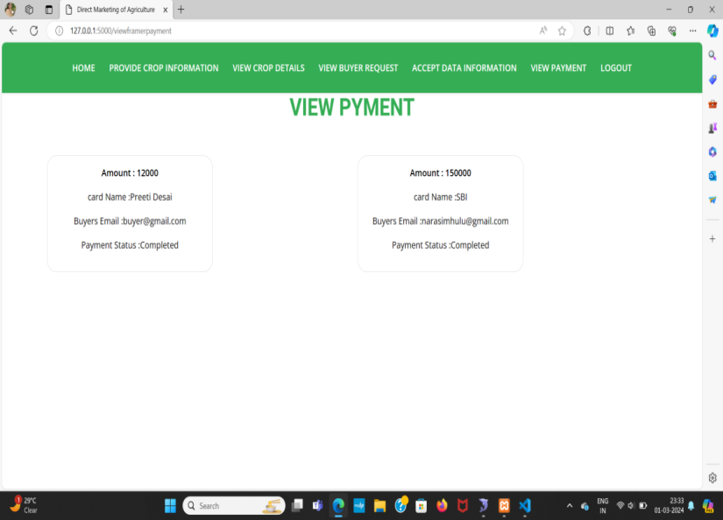

FIGURE 8.10:View Payment Page

The payment made by the buyer can be viewed by the seller/farmer.

# CONCLUSION & FUTURE WORK

The convergence of decentralized traceability and direct marketing is a transformative force in agriculture supply chains. It promotes transparency and trust while empowering farmers through direct consumer connections, reducing reliance on middlemen and increasing profitability. For consumers, this means heightened confidence in food safety and quality through traceability. Additionally, the streamlined supply chains contribute to environmental sustainability by minimizing food miles. This holistic approach aligns economic interests with environmental responsibility, making it a pivotal advancement in agriculture that benefits all stakeholders.

The future scope for this project includes several key enhancements. Firstly, we aim to implement a strong email verification system to enhance security measures. Secondly, we plan to integrate individuals' Aadhaar and bank account details into the system to improve data integrity and validation. These additions will significantly streamline the export processes, ensuring greater efficiency and ease of use for everyone involved.

# REFERENCES

1. M. M. Aung and Y. S. Chang, ‘‘Traceability in a food supply chain: Safety and quality perspectives,’’ Food Control, vol. 39, pp. 172–184, May 2014.
2. T. Bosona and G. Gebresenbet, ‘‘Food traceability as an integral part of logistics management in food and agricultural supply chain,’’ Food Control, vol. 33, no. 2, pp. 32–48, 2013.
3. J. Hobbs, ‘‘Liability and traceability in agri-food supply chains,’’ in Quantifying the Agri-Food Supply Chain. Springer, 2006, pp. 87–102.
4. D. Mao, Z. Hao, F. Wang, and H. Li, ‘‘Novel automatic food trading system using consortium blockchain,’’ Arabian J. Sci. Eng., vol. 44, no. 4, pp. 3439–3455, Apr. 2018.
5. L. U. Opara and F. Mazaud, ‘‘Food traceability from field to plate,’’ Outlook Agricult., vol. 30, no. 2, pp. 239–247, 2001.
6. F. Dabbene and P. Gay, ‘‘Food traceability systems: Performance evaluation and optimization,’’ Comput. Electron. Agricult., vol. 75, no. 2, pp. 139–146, 2011.
7. J. Storoy, M. Thakur, and P. Olsen, ‘‘The TraceFood framework— Principles and guidelines for implementing traceability in food value chain,’’ J. Food Eng., vol. 115, no. 2, pp. 41–48, 2013.
8. M. A. Khan and K. Salah, ‘‘IoT security: Review, blockchain solutions, and open challenges,’’ Future Gener. Comput. Syst., vol. 82, pp. 395–411, May 2018.
9. L. Lucas. Financial Times. (2018). From Farm to Plate, Blockchain Dishes Up Simple Food Tracking. Accessed: Jun. 12, 2018. [Online]. Available: <https://www.ft.com/content/225d32bc-4dfa-11e8-97e4-13afc22d86d4>
10. A. Bogner, M. Chanson, and A. Meeuw, ‘‘A decentralised sharing app running a smart contract on the Ethereum blockchain,’’ in Proc. 6th Int. Conf. Internet Things, 2016, pp. 177–178.
11. K. Salah, M. Rehman, N. Nizamuddin, and A. Al-Fuqaha, ‘‘Blockchain for AI: Review and open research challenges,’’ IEEE Access, vol. 7, pp. 10127–10149, 2019.
12. H. Hasan and K. Salah, ‘‘Combating deepfake videos using blockchain and smart contracts,’’ IEEE Access, vol. 7, no. 1, pp. 41596–41606, Dec. 2019.
13. R. Beck, J. S. Czepluch, N. Lollike, and S. Malone, ‘‘Blockchain-the gateway to trust-free cryptographic transactions,’’ in Proc. ECIS, May 2016, p. 153.
14. M. E. Peck, ‘‘Blockchains: How they work and why they’ll change the world,’’ IEEE Spectr., vol. 54, no. 2, pp. 26–35, Sep. 2017.
15. K. Toyoda, P. T. Mathiopoulos, I. Sasase, and T. Ohtsuki, ‘‘A novel blockchainbased product ownership management system (POMS) for anti-counterfeits in the post supply chain,’’ IEEE Access, vol. 5, pp. 17465–17477, 2017.

**DECENTRALIZED TRACEABILITY AND DIRECT MARKETING OF AGRICULTURAL SUPPLY CHAIN**

Narasimhulu.M,1, a)  Shabana.S , Sai Charan Reddy.N, Sai pranav reddy.G, Sushmitha.C 2,3,4,5b)

*1Assistant Professor, Computer Science and Engineering, Srinivasa Ramanujan Institute of Technology, Anantapur, India.*

*2,3,4,5Computer Science and Engineering, Srinivasa Ramanujan Institute of Technology*

*a)*[*narasimhulu.cse@srit.ac.in*](mailto:narasimhulu.cse@srit.ac.in)*,*

*b)*[*204g1a0595@srit.ac.in*](mailto:204g1a0595@srit.ac.in)

*c)*[*204g1a0584@srit.ac.in*](mailto:204g1a0584@srit.ac.in)

*d)*[*204g1a0590@srit.ac.in*](mailto:204g1a0590@srit.ac.in)

*e)*[*214g5a05A6@srit.ac.in*](mailto:214g5a05A6@srit.ac.in)

**Abstract:** The agriculture sector is facing the major challenges because of the absence of direct supply chain between farmers and buyers. This will lead to vulnerabilities, reduce the farmers income and compromises product quality. To address these issues, we are developing a web portal which facilitates the visibility of farmers profiles making their details accessible to the wide range of buyers. This approach lets buyers to connect with farmers through the portal, allowing them to negotiate and quickly update price agreements.

To enhance transparency and security, our system incorporates Blockchain technology to record and securely store all transactions. Our innovative web portal strives to bridge the gap between farmers and buyers promoting transparency and trust in agriculture transactions. This approach has the potential to benefit both farmers and consumers while promoting sustainable practices within the agricultural sector.

Meal’s safety and corruption risks have necessitated the implementation of powerful traceability measures to ensure product protection during the agricultural deliver chain. Blockchain generation has emerged as a revolutionary system able to offering groundbreaking solutions for commodity traceability in each agriculture and food deliver chains. by means of leveraging blockchain's immutable and decentralized ledger, stakeholders across the supply chain can securely record and tune each level of manufacturing, processing, and distribution. This transparency and duty permit rapid identity and mitigation of dangers, safeguarding the integrity and protection of agricultural products from farm to fork.

**Keywords: Agriculture supply chain, Direct marketing, Blockchain, Traceability.**

**INTRODUCTION**

In today's world, the agriculture supply chain faces numerous challenges, including transparency, traceability, and direct marketing. Farmers struggle to find reliable buyers for their crops, and buyers face challenges in sourcing quality products at fair prices. The farmers get less price than the minimum selling price in the market because of many intermediaries present in the current supply chain. There is no clear and reliable record about the crop, origin, quality, and the final price. There is no direct communication and negotiation between the farmer and the buyer. Lack of transparency in transactions makes it difficult for the farmer and the buyer to trust each other leading to disputes.

To address these issues, our project focus on the development of a decentralized traceability and direct marketing system for agriculture supply chains. This innovative system empowers buyers, sellers, and administrators, fostering a more efficient and transparent marketplace. Buyers can seamlessly register, log in, and access detailed information about sellers' crops, enabling them to make informed decisions. They can also send requests to sellers, view responses, make payments securely, and log out, ensuring a user-friendly experience. Sellers, on the other hand, can register and log in to provide comprehensive crop information, view buyer requests, and track payments effortlessly. This system streamlines the marketing process for sellers, improving their reach and efficiency. Administrators have the capability to log in, manage fixed payments, and maintain the system's integrity. Our decentralized traceability and direct marketing system promise to revolutionize agriculture supply chains, enhancing transparency, trust, and efficiency across the industry.

**LITERATURE SURVEY**

[1] The implementation of a blockchain-based strategy in the agricultural deliver chain is poised to revolutionize operations bearing on monitoring crop fees and making sure traceability. This proposed framework gets rid of the necessity for relied on centralized government and intermediaries, thereby streamlining enterprise operations.

[2] authors have provided an technique geared toward improving the traceability of soybeans in the Agri-food supply chain. Their proposed answer addresses troubles associated with centralized systems while eliminating the reliance on trusted 1/3 parties. This method prioritizes preserving high degrees of integrity, trustability, and security at some stage in the supply chain processes.

[3] Given the escalating concerns surrounding meals protection in each commercial and educational spheres, the centralization of current systems has come to be an increasing number of intricate, main to issues consisting of fraud, tampering, and vulnerability to man-in-the-center assaults.

[4] An author has proposed a traceability scheme integrating threat evaluation and important manage factors (HACCP), blockchain, and internet of things (IoT) technologies, aiming to deal with those challenges comprehensively.

[5] the authors recommend an effective warehousing scheme tailored for Agri-meals product monitoring. They appoint the InterPlanetary record system (IPFS) along with a secondary database to facilitate traceability. IPFS capabilities as a community for decentralized garage and sharing of facts inside a dispensed file gadget. To retrieve information from IPFS, the sale hash is extracted from the secondary database.

[6] an auditable protocol designed to make sure transparency, tamper-proof, and empirical transactions among stakeholders. Leveraging the Ethereum blockchain, the protocol helps online supply chain structures, in particular within the commercial enterprise-to-consumer (B2C) version.

[7] The authors stress the significance of obvious, tamper-evidence, and adaptable tracing of product provenance in the supply chain. To address these requirements, they introduce an innovative solution called the starting place-chain, leveraging each personal and public blockchain technology.

[8] some other organization of authors gives a blockchain-primarily based decentralized traceability procedure and offers a corresponding case take a look at. Their use case illustrates the traceability of merchandise from their origin to the customer's desk, demonstrating the efficacy of various performance systems such as Ethereum and Hyperledger.

**PROPOSED SYSTEM**

The proposed system aims to establish a decentralized traceability and direct marketing platform for agricultural supply chains. Buyers can easily access the system through registration and login, enabling them to view seller crops, send requests, and make payments seamlessly. Sellers, after registering and logging in, can provide crop information, view buyer requests, and track payments received. Additionally, the system empowers the admin to log in, manage fixed payments, and ensure smooth operations. This platform enhances transparency, efficiency, and trust within the agriculture supply chain, promoting fair and direct interactions among stakeholders.

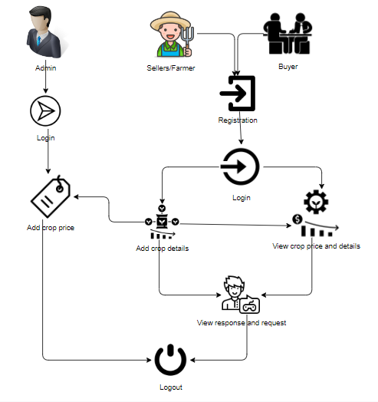

**Figure 1: Block diagram for suggested approach**

**Methodology Overview**

The flow diagram that follows provides an explanation of how the system operates. The steps that make up the overall process areas follows.

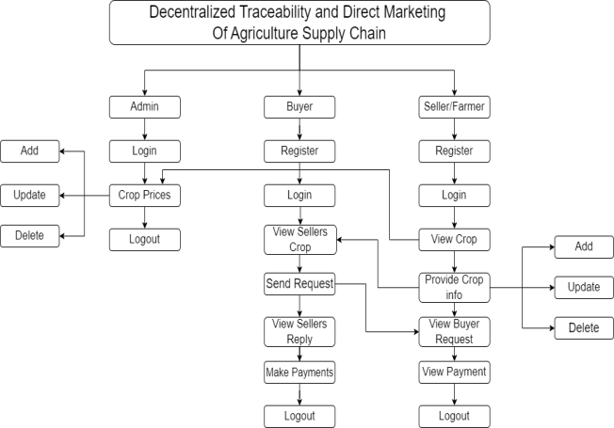

**Figure 2: Flow Diagram for suggested approach**

**System Implementation**

**Modules:**

To develop a decentralized traceability for agriculture supply chains, you can break down the functionality into several modules for the different user roles: Buyer, Seller, and Admin. Here are the modules for each role:

Buyer:

**1. Register:** The buyer will register with their details like name, email, password, address, contact, so after that the buyer will login.

**2. Login:** After registration the buyer will login with their details.

**3. View Seller's Crop Information:** Once the sellers will add the details the buyer can view those details here.

**4. Send Request to Seller:** If the buyer wants the details of crop then buyer will send request to seller.

**5. View Seller Requests:** Displays responses from sellers to the buyer's requests.

**6. Make Payment:** Once the seller accept the request for the crop the buyer has to pay the amount for that crop.

**7. Logout:** Allows buyers to logout securely.

Seller:

**1. Register:** The seller will register with their details like name, email, password, address, contact, so after that the seller will login.

**2. Login:** After registration the seller will login with their details.

**3. Provide Crop Information:** The seller will add there crop details like (crop name, crop category, and quantity and quality).

**4.View Buyer Requests:** When the buyer will send the request for the crop, here the buyer will view and he/she has to accept the request.

**5. View Payments:** Once the buyer will pay the amount for the crops. The seller can view the details of the payment.

**6. Logout:** Allows sellers to logout securely.

Admin:

**1. Login:** The admin will login with default email and password.

**2. Crop price:** The admin is the person he/ she will add the crop price for each and every crop details with that crop name, category, maximum cost, minimum cost and quantity.

**3. Logout:** Allows the admin to log out securely.

A sequence illustration is a type of trade example that indicates how tactics perform with one another and in what order. it's a construct of a communique series Map.

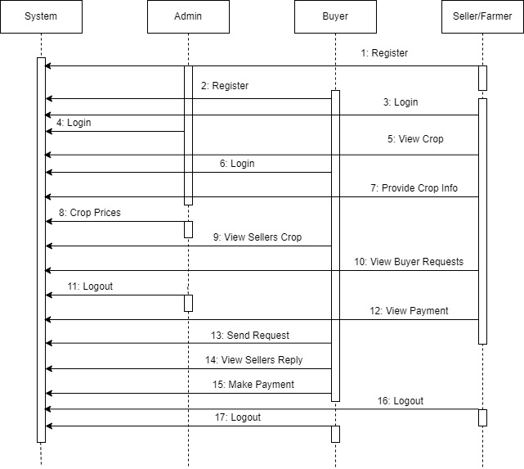

**FIGURE 3: Sequence diagram**

The primary purpose of a use case illustration is to show what gadget features are finished for which locations of the actors within the gadget may be depicted.

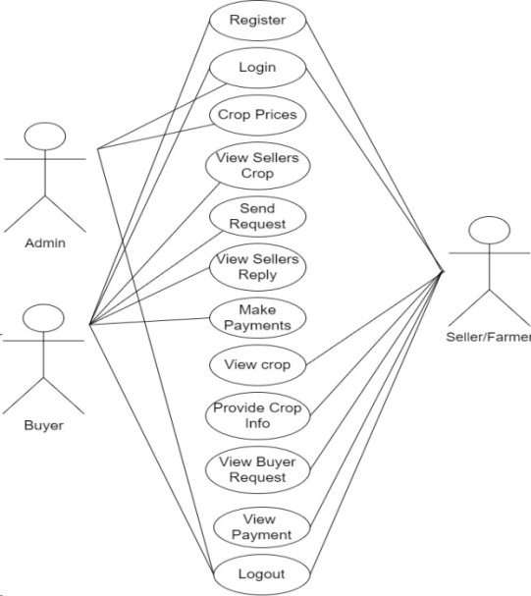

**FIGURE 4: Use Case diagram**

**EXPERIMENTS AND RESULTS**

Given that we are using a web page to demonstrate how the system functions. The outputs from the first to the last step or from the registration stage to the payment viewing stage, are displayed in the photos below. Admin can login and set minimum cost price for the crops. Sellers can register, login, provide crop details and accept the request of buyers for payment process. Buyers can also register, login, view the crop details, send request to sellers for payment.

Home: This is the initial page of the project



**FIGURE 5: Home Page**

User Registration:



**FIGURE 6: Registration page**

User Login:



**FIGURE 7: Login Page**

Adding crop information:



**FIGURE 8: Seller adding the crop details**

View Crop Information:



**FIGURE 9: Buyer Viewing crop details**

Sending Request:



**FIGURE 10: Sending request to seller**

View Response from Sellers:



**FIGURE 11: Request Acceptance**

Payment:



**FIGURE 12: Payment Page**

Payment Status:



**FIGURE 13: Payment Status**

**ACKNOWLEDGEMENT**

We extend our sincere gratitude to the contributors and collaborators involved in the development of this project aimed at Decentralized traceability and direct marketing of agriculture supply chain. Special thanks are extended to the teams and researchers who pioneered the utilization of Traceability , particularly Blockchain technology. Their innovative work forms the foundation of our approach, allowing us to leverage the power of web development and Blockchain for more accurate and efficient payment process. This mission might no longer had been feasible without the collective efforts and knowledge of those committed to advancing era in agriculture deliver chain and traceability.

**CONCLUSION**

On this paper, we proposed a Blockchain based internet portal that helps farmers to promote their merchandise in a transparent way, all of the facts are stored inside the database. There is an direct interaction between sellers and buyers which is crucial for trust and making the payment easier. This system enhances transparency, traceability and trust in the whole process. In future we can implement More security, provide Email Authentication and add rating system.

**REFERENCES**

1. Shivendra, Chiranjeevi, Tipathi, M.K & Maktedar, [“Blockchain Technology in Agriculture Product Supply Chain](https://ieeexplore.ieee.org/document/9395886)”.
2. K. Salah N. Nizamuddin R. Jayaraman and M. Omar, "[Blockchain-based soyabean traceability in agricultural supply chain](https://ieeexplore.ieee.org/stamp/stamp.jsp?arnumber=8718621)" IEEE Access vol. 7 pp. 73295-73305 2019.
3. M. P. Caro, M. S. Ali, M. Vecchio, and R. Giaffreda, ‘‘[Blockchain based tarceability in agri-food supply chain management](https://ieeexplore.ieee.org/document/8373021)’’ in Proc. IoT Vertical Topical Summit Agricult.-Tuscany (IOT Tuscany), May 2018, pp. 1–4.
4. F. Tian, ‘‘[A supply chain traceability system for food safety based on HACCP, blockchain & Internet of Things](https://ieeexplore.ieee.org/abstract/document/7996119),’’ in Proc. Int. Conf. Service Syst. Service Manage., 2017, pp. 1–6.
5. J. Hao, Y. Sun, and H. Luo, ‘‘[A safe and efficient storage scheme based on blockchain and IPFS for agricultural products tracking,](https://www.semanticscholar.org/paper/A-Safe-and-Efficient-Storage-Scheme-Based-on-and-Hao-Sun/759117d27b07ace9d2fa58fa4b7ff6f08bc7a326)’’ J. Comput., vol. 29, no. 6, pp. 158–167, 2018.
6. S. Wang, X. Tang, Y. Zhang, and J. Chen, ‘‘[Auditable protocols for fair payment and physical asset delivery based on smart contracts](https://ieeexplore.ieee.org/document/8792156),’’ IEEE Access, vol. 7, pp. 109439–109453, 2019
7. Z. Li, H. Wu, B. King, Z. B. Miled, J. Wassick, and J. Tazelaar, [‘‘A hybrid blockchain ledger for supply chain visibility,](https://ieeexplore.ieee.org/document/8452028)’’ in Proc. 17th Int. Symp. Parallel Distrib. Comput. (ISPDC), Jun. 2018, pp. 118–125.
8. Q. Lu and X. Xu, ‘‘Adaptable blockchain-based systems: A case study for product traceability,’’ IEEE Softw., vol. 34, no. 6, pp. 21–27, Nov. 2017.
9. L. Lucas. Financial Times. (2018). From Farm to Plate, Blockchain Dishes Up Simple Food Tracking. Accessed: Jun. 12, 2018. [Online]. Available: <https://www.ft.com/content/225d32bc-4dfa-11e8-97e4-13afc22d86d4>
10. A. Bogner, M. Chanson, and A. Meeuw, ‘‘[A decentralised sharing app running a smart contract on the Ethereum blockchain,’’](https://cocoa.ethz.ch/downloads/2017/08/2306_Sharing_App_Final_Publication.pdf) in Proc. 6th Int. Conf. Internet Things, 2016, pp. 177–178.
11. D. Mao, Z. Hao, F. Wang, and H. Li, ‘‘Novel automatic food trading system using consortium blockchain[Novel Automatic Food Trading System Using consotium blockchain](https://www.semanticscholar.org/paper/Novel-Automatic-Food-Trading-System-Using-Mao-Hao/407b9b43f6eac0790b1a11148f3ef4b99d0bf7f1),’’ Arabian J. Sci. Eng., vol. 44, no. 4, pp. 3439–3455, Apr. 2018.
12. F. Dabbene and P. Gay, ‘‘[Food traceability systems: Performance evaluation and optimization](https://ui.adsabs.harvard.edu/abs/2011CEAgr..75..139D/abstract),’’ Comput. Electron. Agricult., vol. 75, no. 2, pp. 139–146, 2011.
13. J. Storoy, M. Thakur, and P. Olsen, ‘‘[The TraceFood framework— Principles and guidelines for implementing traceability in food value chain,](https://www.semanticscholar.org/paper/The-TraceFood-Framework-%E2%80%93-Principles-and-guidelines-Stor%C3%B8y-Thakur/23dfaf19b57e7d6d6f90c732a1f60ddd41a5d7d2)’’ J. Food Eng., vol. 115, no. 2, pp. 41–48, 2013.
14. M. A. Khan and K. Salah, ‘‘[IoT security: Review, blockchain solutions, and open challenges](https://www.academia.edu/38066793/IoT_security_review_blockchain_solutions_and_open_challenges)’’ Future Gener. Comput. Syst., vol. 82, pp. 395–411, May 2018.
15. J. Hobbs, ‘‘[Liability and traceability in agri-food supply chains](https://www.researchgate.net/publication/226514135_Liability_and_traceability_in_agri-food_supply_chains),’’ in Quantifying the Agri-Food Supply Chain. Springer, 2006, pp. 87–102.

# CERTIFICATE

